**NOR FAKHIRA BINTI YUSOF**

**U2000780**

Tutorial 1 (WIC2003)

1. Define the following abbreviation (no explanation needed):

|  |  |  |
| --- | --- | --- |
| * 1. VHSIC   **Very High Speed Integrated Circuit** | * 1. HDL   **Hardware description language** | * 1. VHDL   **Very high-speed integrated circuit hardware description language** |
| * 1. PLD   **Programmable logic device** | * 1. SPLD   **Simple programmable logic device** | * 1. CPLD   **Complex programmable logic device** |
| * 1. FPGA   **Field-programmable gate array** | * 1. VLSI   **Very large-scale integration** | * 1. ULSI   **Ultra large-scale integration** |
| * 1. ASIC   **Application-specific integrated circuit** | * 1. CLB   **Configurable logic block** | * 1. LUT   **Lookup table** |
| * 1. PCB   **Printed circuit board** | * 1. EDA   **Electronic design automation** | * 1. OTP   **One-time programmable** |
| * 1. SRAM   **Static random-access memory** | * 1. CMOS   **Complementary metal-oxide-semiconductor** | * 1. TTL   **Time-to-live** |
| * 1. CAD   **Computer-aided design** | * 1. CAE   **Computer-aided engineering** | * 1. IEEE   **Institute of Electrical and Electronics Engineers** |
| * 1. DoD   **Dial On Demand** | * 1. IP   **Internet Protocol** | * 1. SoC   **System-on-a-chip** |
| * 1. RTL   **Register transfer language** |  |  |

1. What is schematic? Explain why VHDL can overrule schematic design?

**A Schematic is a simplified diagram or drawing of a machine, process, etc., that is meant to be explanatory to the user. VHDL can overrule schematic design because schematic design is only useful when we are only tying together a few off-the-shelf modules (counters, adders, memory, etc). But implementing an actual algorithm (say, a cryptography hashing algorithm) is nearly impossible to do without an HDL (like VHDL or Verilog), since there's no way to describe a system at a behavioral level with schematic symbols.**

1. List six advantages of the VHDL/PLD methodology over traditional digital design.
2. **It supports various design methodologies like Top-down approach and Bottom-up approach.**
3. **It provides a flexible design language.**
4. **It allows better design management.**
5. **It allows detailed implementations.**
6. **It supports a multi-level abstraction.**
7. **It provides tight coupling to lower levels of design.**
8. For which current use was the VHDL language not originally intended?

**Automatic synthesis of hardware**

1. Can every VHDL program that can be simulated be synthesized? If not, explain why?

**Certain VHDL constructs are unsynthesizable and simply cannot be used for synthesis because there are some parts of Verilog and VHDL that the FPGA simply cannot implement.**

1. What is simulation & synthesis?

**Simulation is the process of describing the behaviour of the circuit using input signals, output signals and delays.**

**Synthesis is the process of constructing a physical system from an abstract description using a predefined set of building blocks.**

1. The common FPGA process technologies are PROM, EPROM, EEPROM, flash, anti-fuse and SRAM based. State their differences using a table.

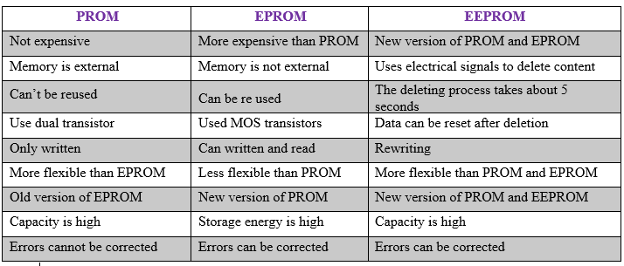

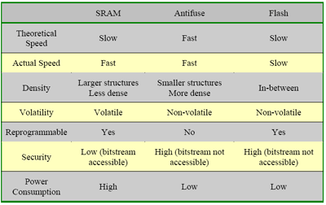

1. State the differences between
   1. ASIC, FPGA and CPLD

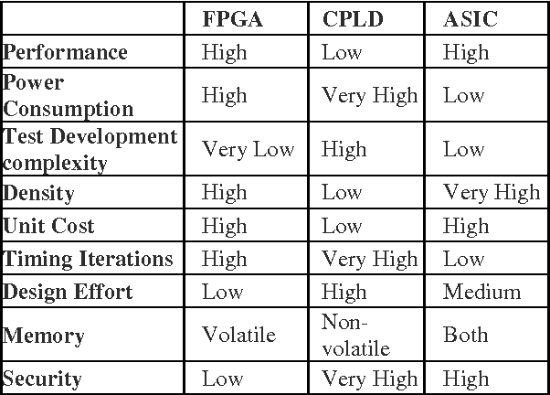

* 1. VHDL and Verilog

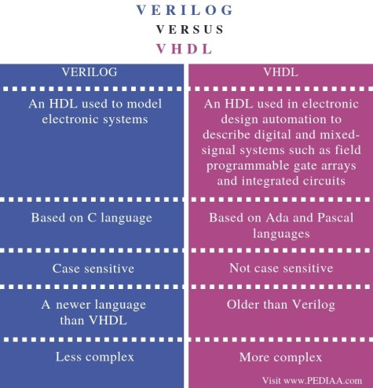

* 1. SRAM in memory device and SRAM in programmable device

|  |  |
| --- | --- |
| RAM | SRAM |
| RAM is a type of volatile memory that loses data when power is disconnected. | The SRAM is a type of RAM, that is synchronous and is formed from internal latches. |
| It is overall more costly than SRAM because it contains both Static RAM (SRAM) and Dynamic RAM (DRAM). | It is less costly than RAM. |
| It is used by OS and application software. | It is used by high-speed registers, caches and smaller memory banks (e.g. frame buffer). |
| Examples of RAM comprise Mac computers that have between 128 and 512 MB of RAM. | Examples of SRAM comprise IBM Microelectronics’ PC compatible SRAMS that are sold in 52 pin PLCC or 100 pin TQFP packages. |
| It may or may not use busses. | It does not require busses. |
| It is the most basic form of computer memory that helps the fast startup and fast shutdown of a computer. | It is an integrated chip that is quick and easy to control. |
| It is contains the Static RAM (SRAM) and Dynamic RAM (DRAM). | It is contained inside a RAM. |
| Capacitors or Transistors are used to store data in RAM. | Transistors are used to store information in SRAM. |
| Transistors are used due to which refreshing is required at regular intervals. | Capacitors are not used due to which no refreshing is required. |
| It is a combination of low and high density devices. |  |

* 1. PLA and PAL

**The difference between PLA and PAL is that PAL has a programmable AND array followed by a fixed or array. Whereas, PLA has a programmable AND array followed by a programmable OR array.**